Q. Demonstrate DHCP router in packet Tracer.
Aim:- To demonstrate DHCP server in packet Tracer. Setup:
(1). Router ,switch C 2 Pcs.
(2).Connect the Pcs to switch and connect switch t the router.
(3).Give router a ip address then in Pc0 C Pc1 click the radio button of DHCP in the ip configureration panel the values will be assingned directly.

Topology:
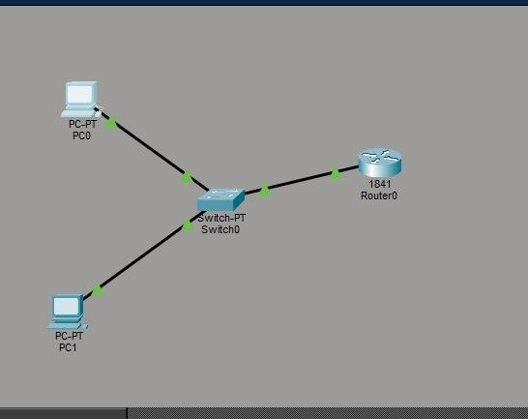

Code:
Router> enable
Router# configure terminal

Router(config)#
Router(config)# interface fastEthernet0/0
Router(config-if)# ip address 192.168.10.1 255.255.255.0 Router(config-if)# no shutdown
Router(config-if)# exit
Router(config)# ip dhcp pool MYPOOL
Router(dhcp-config)# network 192.168.10.0 255.255.255.0
Router(dhcp-config)# default-router 192.168.10.1
Router(dhcp-config)# dns-server 8.8.8.8 Router(dhcp-config)# exit

Verification: In Both PCs Command Prompt.

PC0:
C:\ipconfig
C:\>ping 192.168.10.1
Output:-
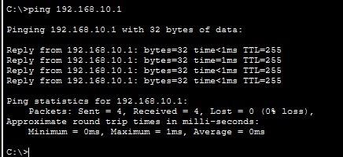
Conclusion:The above Topology has been executed successfully.

